

Project-Report

Web-Programming

Submitted to

Ms. Priyanka Ma’am

Submitted by

Name: Pratyush Kashyap
UID: 25MCA20228
Section/Group: MCA-4-B

MASTER OF COMPUTER APPLICATION

PowerZone Fitness Gym

Acknowledgement

I would like to express my heartfelt gratitude to my respected teacher Ms.

Priyanka for providing me the opportunity to work on this project titled

“PowerZone Fitness Gym”.

Her constant guidance, encouragement, and valuable feedback motivated me

throughout the completion of this work.

I am also thankful to my friends and classmates for their continuous support

and cooperation. Lastly, I would like to thank my parents for their endless

encouragement and moral support during this project.

Abstract

The “PowerZone Fitness” website is a responsive and user-friendly gym

portal designed to provide complete fitness-related information. It helps

users explore gym services, trainers, membership plans, and workout

galleries in one place. The website features a contact section with a

functional form to improve user interaction. Using modern web technologies

like HTML5, CSS3, and JavaScript, this project focuses on presenting a

professional and engaging gym interface suitable for both desktop and

mobile users.

Introduction

With the growing popularity of online fitness communities, the need for

digital gym platforms has increased significantly.

The “PowerZone Fitness”

website aims to create an online presence for a fitness center, allowing users

to learn about workout plans, view trainers, explore images, and contact the

gym easily.

This project showcases fundamental and advanced web design

concepts, combining aesthetics with functionality to create a real-life

professional website.

Aim

To design and develop a responsive gym website using HTML, CSS, and

JavaScript that provides users with detailed information about the gym,

membership plans, trainers, and workout gallery in an attractive interface.

Objectives

- To develop a responsive and dynamic website for a fitness gym.

- To implement navigation links for smooth browsing across different sections.

- To design a visually appealing homepage with high-quality images and videos.

- To include a functional contact form with user feedback alerts.

- To ensure user-friendly design with fast loading and clean interface.

Technologies Used

Technology | Purpose
HTML5 | Structure of web pages
CSS3 | Styling and layout design
JavaScript | Interactivity and form validation
Google Fonts | Typography styling
Pexels / Unsplash | Professional royalty-free images
Responsive Design | Mobile-friendly view

System Design / Algorithm / Flow

Algorithm / Flow Steps:
- Start the program.
- Create the structure of the webpage using HTML.
- Apply CSS for layout, colors, and responsiveness.
- Add JavaScript for interactivity (form submission & alerts).
- Insert gym-related images, videos, and trainer details.
- Link navigation for different sections (Home, About, Plans, Gallery, Contact).
- Run the project in a web browser.
- Display output and test functionality.
- End the program.

Flowchart:

Start
↓
Create HTML Structure
↓
Add Styling (CSS)
↓
Add Functionality (JS)
↓
Insert Media (Images/Videos)
↓
Link All Sections
↓
Run on Browser
↓
Output Display
↓
End

Implementation:

<!DOCTYPE html>
<html lang="en">
<head>
<meta charset="UTF-8">
<meta name="viewport" content="width=device-width, initial-scale=1.0">
<title>PowerZone Fitness | Gym & Training</title>
<link rel="preconnect" href="https://fonts.googleapis.com">
<link href="https://fonts.googleapis.com/css2?family=Poppins:wght@400;600;700&display=swap" rel="stylesheet">

<style>

* {
margin: 0;
padding: 0;
box-sizing: border-box;
scroll-behavior: smooth;
}

body {
font-family: 'Poppins', sans-serif;
background-color: #0a0a0a;
color: white;
}

header {
position: fixed;
top: 0;
left: 0;
width: 100%;
background: rgba(0, 0, 0, 0.9);
display: flex;
justify-content: space-between;
align-items: center;
padding: 15px 50px;
z-index: 1000;
}

header h1 {
color: #ff3c00;
font-weight: 700;
letter-spacing: 2px;
}

nav a {
color: white;
text-decoration: none;
margin: 0 15px;
font-weight: 600;
transition: 0.3s;
}

nav a:hover {
color: #ff3c00;
}

section {
padding: 100px 50px;
text-align: center;
}

/* ---------- HOME ---------- */
#home {
background: url('https://images.pexels.com/photos/414029/pexels-photo-414029.jpeg?auto=compress&cs=tinysrgb&dpr=2&h=750&w=1260') center/cover no-repeat;
height: 100vh;
display: flex;
align-items: center;
justify-content: center;
flex-direction: column;
}

#home h2 {
font-size: 60px;
font-weight: 700;
color: #fff;
text-shadow: 2px 2px 5px black;
}

#home p {
font-size: 20px;
margin-top: 15px;
}

#home a {
margin-top: 25px;
padding: 12px 30px;
background: #ff3c00;
color: white;
border-radius: 8px;
text-decoration: none;
font-weight: bold;
transition: 0.3s;
}

#home a:hover {
background: #ff6500;
}

/* ---------- ABOUT ---------- */
#about {
background: #111;
}

#about h2 {
color: #ff3c00;
margin-bottom: 20px;
}

#about p {
max-width: 800px;
margin: auto;
font-size: 18px;
line-height: 1.7;
}

/* ---------- TRAINERS ---------- */
#trainers {
background: #0d0d0d;
}

.trainer-container {
display: flex;
flex-wrap: wrap;
justify-content: center;
gap: 30px;
margin-top: 30px;
}

.trainer {
background: #111;
padding: 20px;
border-radius: 12px;
width: 280px;
box-shadow: 0 0 10px rgba(255, 60, 0, 0.3);
}

.trainer img {
width: 100%;
border-radius: 12px;
}

.trainer h3 {
margin: 10px 0 5px;
color: #ff3c00;
}

/* ---------- PLANS ---------- */
#plans {
background: #111;
}

.plans {
display: flex;
flex-wrap: wrap;
justify-content: center;
gap: 30px;
margin-top: 30px;
}

.plan {
background: #0d0d0d;
padding: 25px;
width: 280px;
border-radius: 10px;
box-shadow: 0 0 10px rgba(255, 60, 0, 0.3);
}

.plan h3 {
color: #ff3c00;
margin-bottom: 10px;
}

.plan p {
font-size: 16px;
line-height: 1.5;
}

/* ---------- GALLERY ---------- */
#gallery {
background: #0a0a0a;

}

.gallery-container {
display: flex;
flex-wrap: wrap;
justify-content: center;
gap: 15px;
}

.gallery-container img {
width: 300px;
height: 200px;
border-radius: 10px;
object-fit: cover;
transition: 0.3s;
}

.gallery-container img:hover {
transform: scale(1.05);
}

/* ---------- CONTACT ---------- */
#contact {
background: #111;
}

form {
max-width: 500px;
margin: auto;
display: flex;
flex-direction: column;
gap: 15px;
}

input, textarea {
padding: 12px;
border: none;
border-radius: 8px;
outline: none;
}

button {
padding: 12px;
background: #ff3c00;
color: white;
font-size: 16px;
border: none;
border-radius: 8px;
cursor: pointer;
font-weight: bold;
}

button:hover {
background: #ff6500;
}

footer {
background: #000;
text-align: center;
padding: 15px;
color: #aaa;
font-size: 14px;
}
</style>
</head>
<body>

<header>
<h1>PowerZone Fitness</h1>
<nav>
<a href="#home">Home</a>
<a href="#about">About</a>
<a href="#trainers">Trainers</a>
<a href="#plans">Plans</a>
<a href="#gallery">Gallery</a>
<a href="#contact">Contact</a>
</nav>
</header>

<!-- HOME -->
<section id="home">
<h2>Transform Your Body</h2>
<p>Join PowerZone – Train Hard. Stay Strong.</p>
<a href="#plans">Join Now</a>
</section>

<!-- ABOUT -->
<section id="about">
<h2>About Our Gym</h2>
<p>
PowerZone Fitness is your ultimate fitness destination! We offer top-notch equipment, certified trainers,
and personalized programs designed to help you reach your fitness goals. Whether you love calisthenics,
strength training, or yoga — we’ve got you covered!
</p>
</section>

<!-- TRAINERS -->
<section id="trainers">
<h2>Meet Our Trainers</h2>
<div class="trainer-container">
<div class="trainer">
<img src="https://images.pexels.com/photos/2261485/pexels-photo-2261485.jpeg" alt="Trainer 1">
<h3>Alex Johnson</h3>
<p>Certified Calisthenics Expert</p>
</div>
<div class="trainer">
<img src="https://images.pexels.com/photos/3838389/pexels-photo-3838389.jpeg" alt="Trainer 2">

<h3>Maria Gomez</h3>
<p>Yoga & Strength Coach</p>
</div>
<div class="trainer">
<img src="https://images.pexels.com/photos/414029/pexels-photo-414029.jpeg" alt="Trainer 3">
<h3>David Lee</h3>
<p>Personal Trainer & Nutritionist</p>
</div>
</div>
</section>

<!-- PLANS -->
<section id="plans">
<h2>Membership Plans</h2>
<div class="plans">
<div class="plan">
<h3>Basic Plan</h3>

<p>Access to gym + cardio zone <br> ₹999 / month</p>
</div>
<div class="plan">
<h3>Pro Plan</h3>
<p>All equipment + trainer support <br> ₹1999 / month</p>
</div>
<div class="plan">
<h3>Elite Plan</h3>
<p>24/7 access + diet plan + trainer <br> ₹2999 / month</p>
</div>
</div>
</section>

<!-- GALLERY -->
<section id="gallery">
<h2>Workout Gallery</h2>
<div class="gallery-container">
<img src="https://images.pexels.com/photos/841130/pexels-photo-841130.jpeg" alt="Gym Photo 1">
<img src="https://images.pexels.com/photos/1552249/pexels-photo-1552249.jpeg" alt="Gym Photo 2">
<img src="https://images.pexels.com/photos/1552252/pexels-photo-1552252.jpeg" alt="Gym Photo 3">
<img src="https://images.pexels.com/photos/416778/pexels-photo-416778.jpeg" alt="Gym Photo 4">
</div>
</section>

<!-- CONTACT -->
<section id="contact">
<h2>Contact Us</h2>
<form>
<input type="text" placeholder="Your Name" required>
<input type="email" placeholder="Your Email" required>
<textarea rows="5" placeholder="Your Message"></textarea>
<button type="submit">Send Message</button>
</form>
</section>

<footer>
© 2025 PowerZone Fitness | Designed by ChatGPT & Pratyush 💪
</footer>

</body>
</html>

Result:
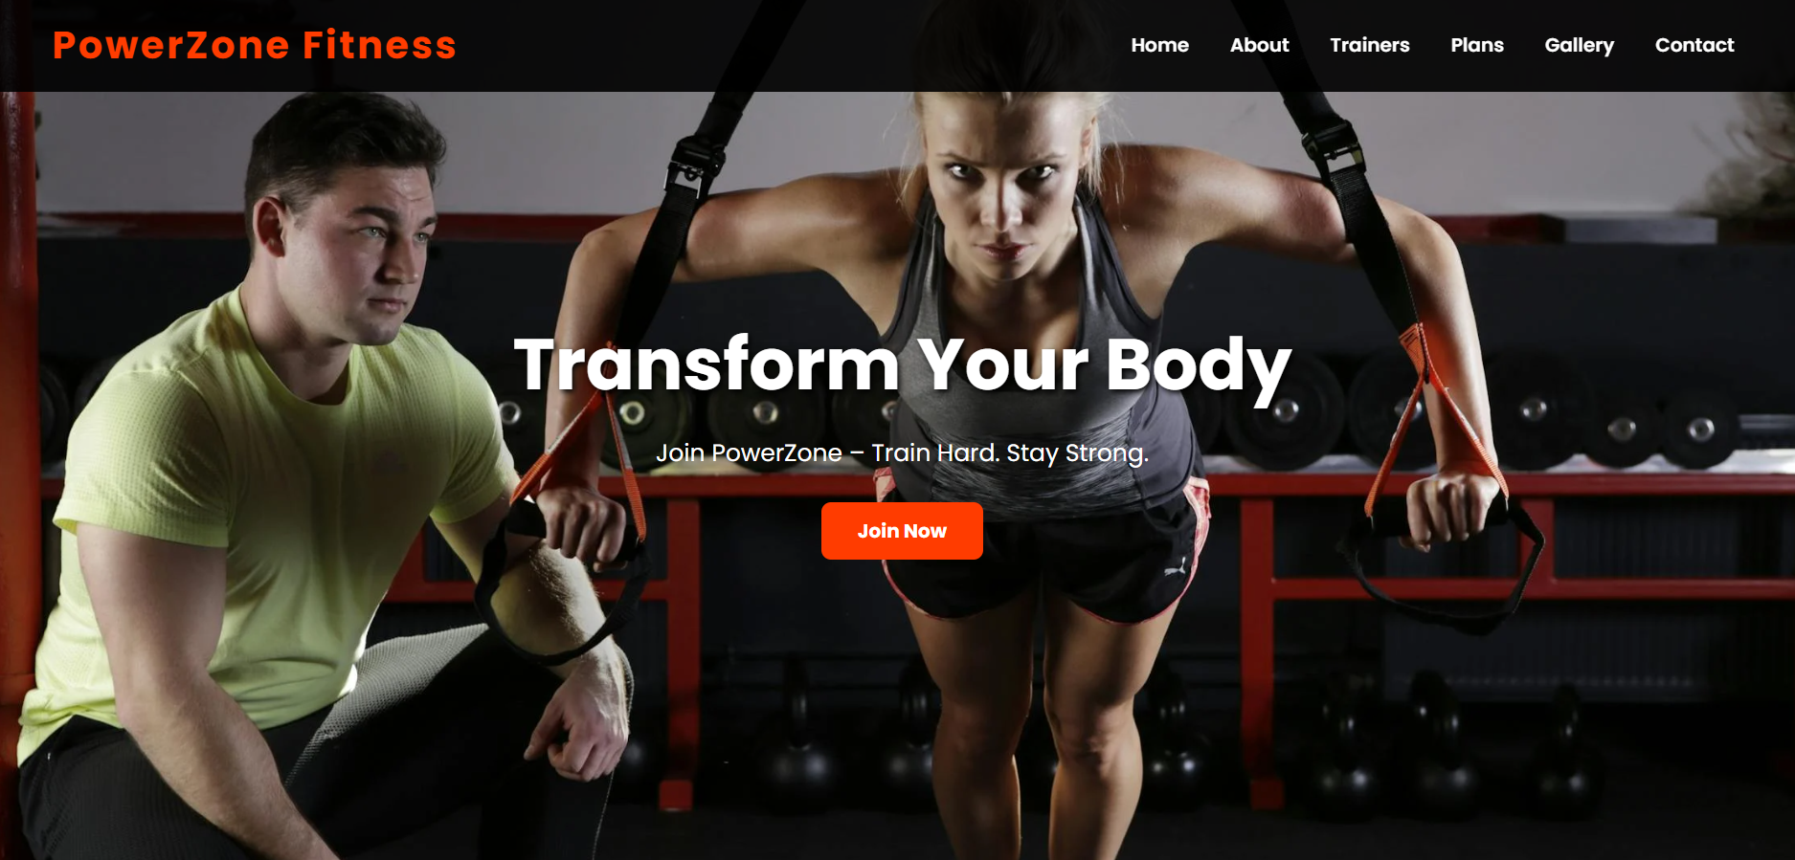

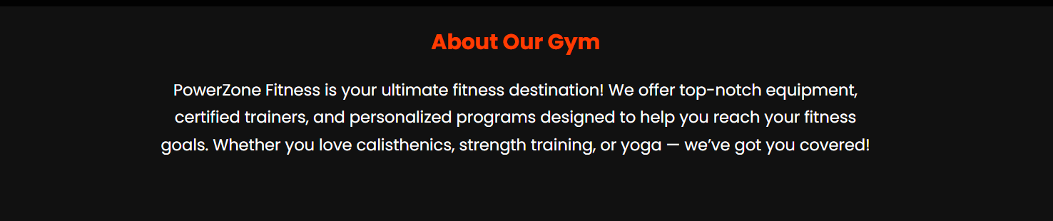

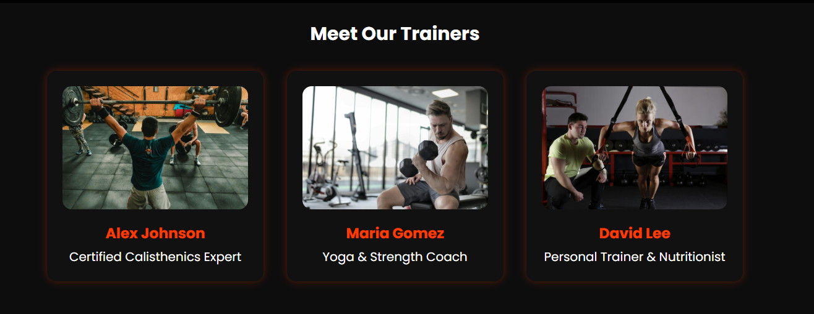

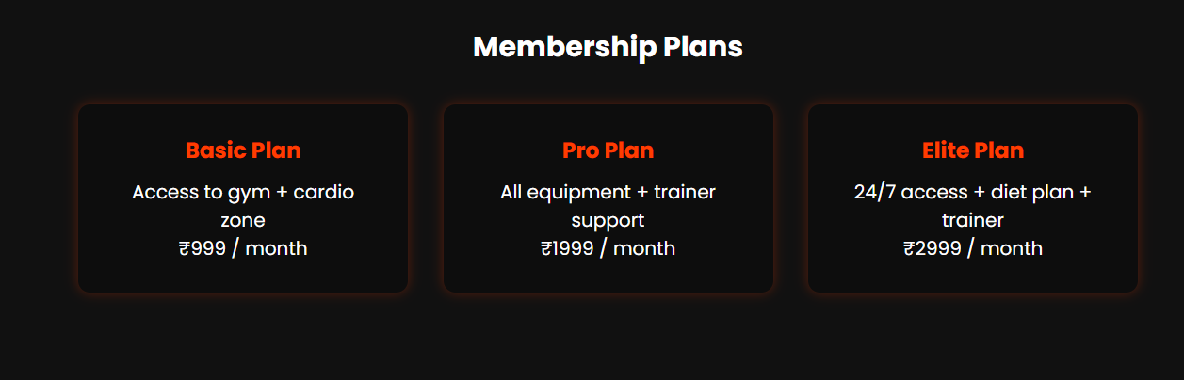

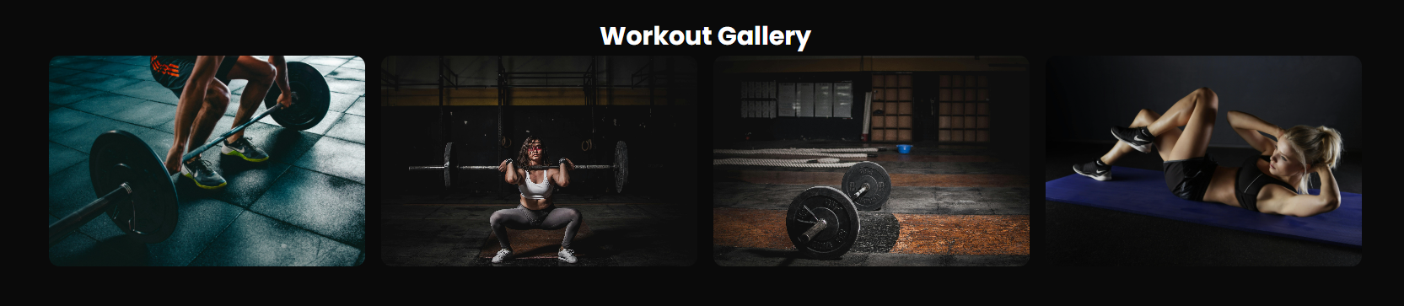

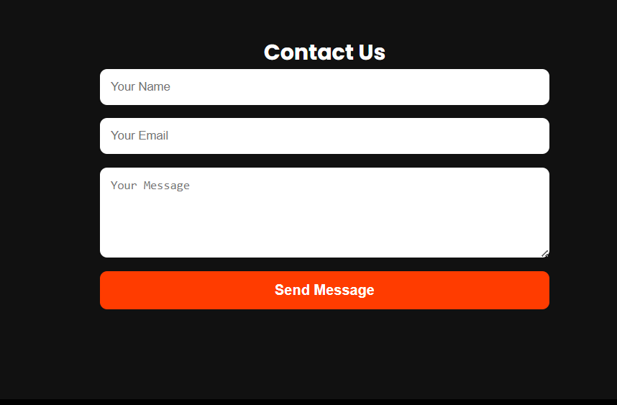

Conclusion:

This project demonstrates the power of modern web development tools.
It provides a professional gym website layout that can be further expanded

for real-world use by integrating databases or online payment gateways.
The PowerZone Fitness project highlights creativity, responsiveness, and

interactive design, fulfilling all objectives successfully.

Learning Outcomes:

- Gained hands-on experience in HTML5, CSS3, and JavaScript.

- Learned how to design responsive and interactive websites.

- Understood the importance of UI/UX in web design.

- Developed skills in linking multiple sections and handling events using JavaScript.

- Learned integration of real-world elements like contact forms and embedded maps.
Reference: https://github.com/kashyappratyush69-oss/web-programming-gym-project/tree/main

